IHE Work Item Proposal (Detailed)

# Proposed Work Item: Medical Device Interoperability Reference Architecture (MDIRA)

Proposal Editor: Todd Cooper

Work Item Editor: JHU/APL Team, incl. Todd Cooper

Date: 2021.02.18

Version: 1.0

Domain: Devices / DPI Program

**Summary**

The Medical Device Interoperability Reference Architecture (MDIRA) IHE detailed profile proposal (DPP) leverages the well-established IHE International processes, technical framework (TF) specifications and conformity assessment (CA) testing capabilities, to advance the creation of a MDIRA-compliant ecosystem of products. The MDIRA specification, developed by a research team at Johns Hopkins University / Applied Physics Lab (JHU/APL)[1], applies an Integrated Clinical Environment (ICE) framework to create a reference architecture that is tailored to use cases supporting trauma care in austere environments requiring autonomous medical technology (including robotics) and remote connected care / telemedicine.

The JHU/APL team created a MDIRA Reference Implementation (RI) utilizing the ISO/IEEE 11073 Service-oriented Device Connectivity (SDC) standards, which will form the technical basis for this IHE MDIRA Profile technical approach. The MDIRA Supplement will leverage other existing and emerging IHE profiles including the Service-oriented Device Point-of-care Interoperability (SDPi) profiles, which profile the same IEEE 11073 SDC standards as the RI.

This profile supplement fulfills an early use case identified for the joint IHE-HL7 Gemini MDI (SDPi+FHIR) project and will be primarily developed within the IHE DEV / DPI Program group.

The project will utilize the same approach being advanced for the IHE SDPi Supplement, including an emerging IHE TF publication approach, as well as formal requirements management and traceability from use cases to CA testing of system component product interfaces. Additionally, the project will work to create open-source libraries and test tooling that will help keep the adoption and implementation hurtles at a level supporting all stakeholders, small and large.

Intent is to develop and publish an initial MDIRA Supplement (1.0) draft for Trial Implementation by late 2021, with plug-a-thon (PAT) events beginning in 2021 and IHE Connectathon (CAT) testing in 2022.

# The Problem

Under auspices of the US Army Medical Research and Development Command (MRDC), The Johns Hopkins University / Applied Physics Lab (JHU/APL) and partnering organizations have been conducting applied research ***for technical architectures to support autonomous medical systems for prolonged care in austere environments and hospitals of the future***. This resulted in the specification of a Medical Device Interoperability Reference Architecture (MDIRA) that utilizes the Integrated Clinical Environment (ICE) framework standardized by ASTM and now AAMI 2700 series. In building the first MDIRA Reference Implementation (RI), the MDIRA team utilized the ISO/IEEE 11073 Service-oriented Device Connectivity (SDC) standards, creating a service-oriented ICE prototype demonstration implementation of the MDIRA specification.

The specific challenges and opportunities related to Device Point-of-care Interoperability (DPI) is well established … for decades. The specific APL MDIRA program value proposition is well illustrated in the video referenced in the following section. Once the reference implementation is completed, though, demonstrating the feasibility and value of the MDIRA, the next challenge is how to advance toward realizing MDIRA-compliant ICE systems, including MDIRA compliance of the medical devices that comprise those systems. A key bridge to that objective is the development of profiles that will guide developers in the use of the interoperability standards underlying MDIRA for core MDIRA/ICE[2] use cases.

During the development of this MDIRA DPP, the question was raised: Why is a MDIRA profile required vs. simply using SDC or defining an SDPi “option” for MDIRA support? This question resulted in a rationale that included points central for motivating any IHE profile development, including:

1. Unique use case narratives that are supported by but not directly addressed in other IHE profiles (see section 3)
2. Architectural approach (MDIRA/ICE) is unique to that of other IHE DEV profiles, including SDC/SDPi
3. Profile will define unique new actors & transactions & content modules
   1. Yes, the profile will extensively leverage SDPi and other profiles
   2. Yes, this will (should) greatly reduce the complexity of this proposed profile
   3. But … the “value add” for MDIRA will be more clearly reflected in the actors and transactions and possibly content modules to be specified
4. Specific Requirements Bindings to the MDIRA Specification
   1. These requirements are not otherwise covered by other profiles and represent a unique set of capabilities that must be supported by implementers
5. Conformity Assessment (testing to product certification) desired at the MDIRA level
   1. “Genuine MDIRA” labeling should be directly supported by IHE CA
6. Different stakeholder community
   1. The stakeholders advancing MDIRA/ICE are similar in some regards to other MDI stakeholders (e.g., those advancing SDPi profiles), but
   2. They represent a significantly different interest group and ecosystem, therefore
   3. Both business and technical drivers are significantly different

Developing a separate MDIRA profile will allow that community of interest to apply the 80/20 rule: existing IHE profiles, processes and tooling should supply 80% of the elements needed to advance MDIRA/ICE-based connectivity, with the group focused on the 20% “value add”.

# Use Cases

The MDIRA project use case narrative is delineated in the video posted on the [project’s public web site](https://secwww.jhuapl.edu/mdira/). In addition, MDIRA Specification V2.0 – Appendix includes a use case narrative that provides an increased level of detail. Use cases that derive from these narratives align with those documented in the [IHE SDPi White Paper](https://www.ihe.net/uploadedFiles/Documents/PCD/IHE_PCD_WP_SDPi_Rev1-1_Pub_2019-11-01.pdf), as well as several of the ICE-related use cases in the [SDPi White Paper – Use Case Compendium document](https://www.ihe.net/uploadedFiles/Documents/PCD/IHE_PCD_WP_SDPi_UseCases_Rev1-1_Pub_2019-11-01.pdf).

Specific MDIRA use cases focus on:

***Trauma and critical care in austere environments, including military conflict and natural disaster contexts, and “hospital of the future” technologies***

“Austere environments” includes disaster response, both natural and manmade, where the normal emergency response provisions may no longer exist and responding with medical care may be significantly delayed. The MDIRA profile will leverage content from the MDIRA 2.0 specification and the SDC-based reference implementation (e.g., see sequence diagram figures in section 5 below), as well as the SDPi Supplement TF-1 Appendix C MDI Use Cases, such as Isolation Point of Care.

Note: The intent is to define specific MDIRA use cases and scenarios using the Gherkin detailed specifications and mapping to ReqIF specifications, consistent with the approach taken for the SDPi Supplement and related publication and test tooling.

Use case selection and description will be focused on the *unique value propositions* for MDIRA, but will leverage the foundational plug-and-trust use cases a la SDC/SDPi use cases. These will include narratives exploring:

1. Capabilities and benefits related to Supervisor-based MDI (MDIRA/ICE)
2. Data logging for analytics, forensic analysis, care quality & system operational improvement
3. Autonomous Patient Therapies / Therapeutic Closed-loop Control
4. External systems integration including telemedicine and care coordination for remote connected care / mobile health (see *Figure 1 MDIRA System Component Model* below)

See also a similar discussion and list below in “*New transactions (standards used)*”.

Examples of use cases detailed in the SDPi “compendium” (see reference above) include (using the compendium’s nomenclature):

NITRD.1 – Seamless changes of medical devices

NITRD.3 – Supervisory control established

NITRD.4 – Autonomous patient therapy

NITRD.7 – Black Box Recorder

UC.6 ICE.6 - Physiological Closed Loop Control (PCLC)

UC.7 ICE.7 - Medical Device Plug-and-Play Interoperability (MD PnP)

Clearly there are a wealth of use cases to select from and will be an initial task for the MDIRA profile project team when developing the profile (see section 5 “*Breakdown of tasks that need to be accomplished*” below).

# Standards & Systems

The Gemini SDPi+FHIR program’s [Hanging Gardens framework](https://confluence.hl7.org/pages/viewpage.action?pageId=82913506#HangingGardensFramework-HangingGardensModel"HangingGardens"SESMDIModel-GeminiSDPi+FHIRStandardsCoordinationModel) establishes the context for the MDIRA profile being proposed. Specifically, the IHE Devices MDIRA profile would be part of the “*SDPi+FHIR Profiles / IGs*” layer, and would leverage the other standards identified in the model, including:

1. [JHU/APL MDIRA Specification](https://secwww.jhuapl.edu/mdira/) (ver 2.0), including *Section 7 References*
2. AAMI 2700-1 ICE standard & 2700-2-1 Forensics Data Logger (draft) standard
3. [IHE SDPi Profiles](https://confluence.hl7.org/pages/viewpage.action?pageId=82906654#Specifications:SDPiIHEProfiles-SDPi-FrameworkModel), as well as other IHE DEV and ITI profiles
4. ISO/IEEE 11073 Service-oriented Device Connectivity (SDC) standards, including
   1. 11073-10207 SDC/BICEPS
   2. 11073-20701 SDC/SOMDA
   3. 11073-20702 SDC/MDPWS
   4. 11073-1070x SDC/Participant Key Purposes standards (in draft)
5. ISO/IEEE 11073-1010x medical device nomenclature standards
6. HL7 FHIR & appropriate FHIR implementation guides (IG) & IHE profiles
7. HL7 Version 2 & appropriate IGs
8. IETF RFC 5424 Syslog Protocol

Note: Items (1) and (2) are both included in the “*Ref. Arch. / Frameworks*” layer.

Standards related to SES MDI[3] (e.g., ISO/IEC 80001-1 or 82304-1) are not called out explicitly in this proposal but will be factored in for the actual MDIRA profile.

# Technical Approach

The MDIRA 2.0 specification includes the following *Figure 1* architectural component diagram:

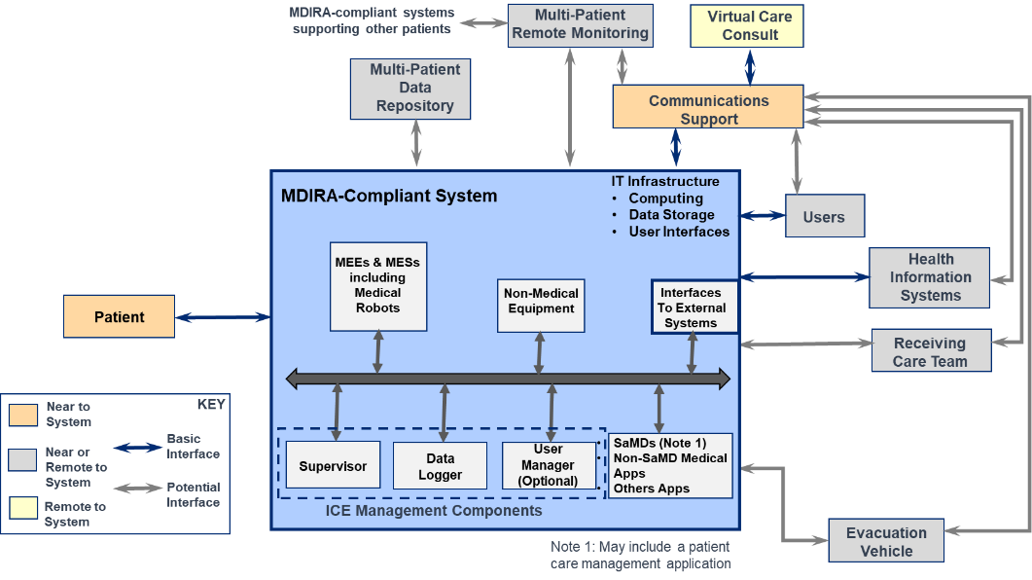

Figure MDIRA System Component Model

Components included in the “blue” MDIRA-Compliant System box represent the core *actors* that would be included in this IHE MDIRA Profile (see *New Actors* section below); whereas the systems outside would be represented by *external actors* that in most cases, may be implemented using other IHE technical framework profiles, especially in the IHE Devices (“DEV”) Technical Framework (TF) and the I.T. Infrastructure (“ITI”) TF. This model, along with the detailed descriptions and specifications in the MDIRA (2.0) specification will guide the technical implementations supported by the IHE MDIRA DPP, with support for some components such as Supervisor and Data Logger identified as required for profile “version 1.0” and others such as “Evacuation Vehicle” targeted for subsequent profile versions.

As a starting point, the system architecture model above was prototyped in a reference implementation (RI) per *Figure 2*:

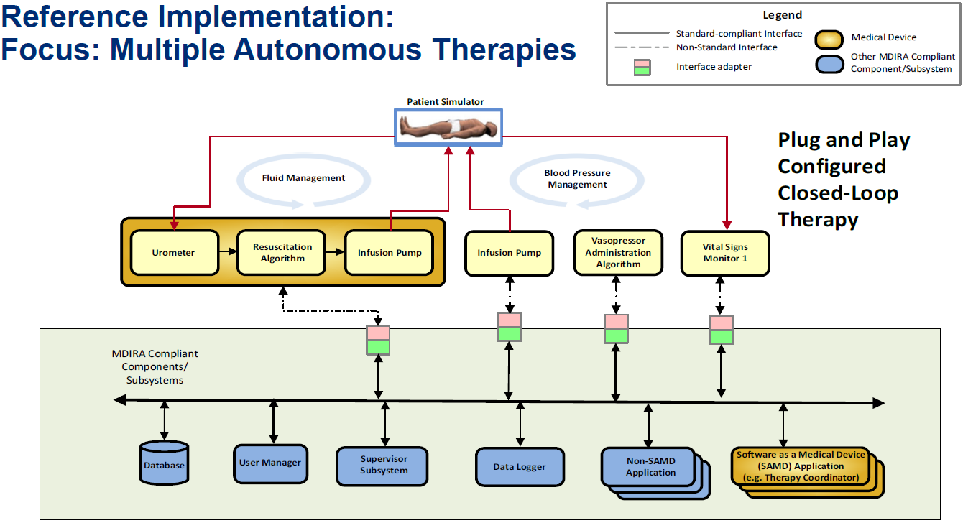

Figure MDIRA Reference Implementation Diagram

Consider the key elements from this RI, which was built utilizing ISO/IEEE 11073 SDC standards-based technologies, that inform the profile proposal’s technical approach:

1. ***“Multiple Autonomous Therapies”*** –
   1. A VERY high bar to be sure; however, this is the aspiration and core “focus” of the MDIRA project;
   2. Any interoperability approach must allow a clear pathway toward realization of *autonomous medical system* technologies;
   3. Additionally, multiple *concurrent* therapeutic clinical algorithms must be supportable (i.e., “Fluid Management” and “Blood Pressure Management”;
      * Note: some components are singletons (e.g., Supervisor) and others may be multiples (health software applications)
   4. Therapies, including “clinical algorithms” should be implementable in multiple technologies, such as standalone devices and systems, as well as health software applications (including “apps” and SAMD);
2. ***“Plug and Play Configured Closed-Loop Therapy”*** –
   1. Seamless real-time (at the point of connection) integration, configuration, and operation of MDIRA components is foundational to any MDIRA-based system;
   2. Configured in this case implies a Supervisor that is ensuring safe configuration and dynamic operation (e.g., component health status) of all system components;
   3. Closed-Loop Therapy here integrates “autonomous” and “therapeutic clinical algorithms” mentioned in (1) above;
   4. NOTE: The MDIRA and its SDC-based RI are focused on defining and demonstrating a prototype of an architecture specification, and not the specific algorithms specific algorithms that might be implemented using MDIRA-compliant technologies; the examples in *Figure 2* above are just that: examples;
      * In other words, *MDIRA in no way seeks to standardize medicine or health care; it is only a health informatics architecture that is tailored for health and medical application purposes*
3. ***“MDIRA Compliant Components / Subsystems”*** –
   1. The light green box labeled “MDIRA Compliant Components / Subsystems” indicates the MDIRA RI system components that support MDI constructs; the systems above the box are existing systems that may be utilized to support the needed RI functionality (see 6. MDIRA Adaptors below);
   2. MDIRA conformity is not addressed within the specification (e.g., by defining explicit Implementation Conformity Statement (ICS) tables or similar); though this may change in future versions of the specification or in collateral specifications;
   3. For the purposes of the MDIRA profile, Conformity Assessment (CA) will be supported utilizing the standard mechanisms for IHE technical framework profiles;
   4. Note: The IHE SDPi profiles are advancing a new level of requirements specification and management; it is anticipated that a similar approach will be utilized in the MDIRA profile, especially since it will be primarily built upon the SDPi profiles; for example,
      * TF-1 Appendix B may include MDIRA ICS tables or similar
      * TF-1 Appendix C may be crafted with Gherkin-based use case requirements specifications
      * TF-1 MDIRA Profile specification will include ReqIF-flagged constructs and possibly MDIRA requirements bindings
      * MDIRA specification requirements may be abstracted into a ReqIF-based Architecture Layer specification file to enable traceability from CA testing of a component interface back to the requirement in the specification
4. ***System Component Optionality*** –
   1. The conditionality of MDIRA system components (i.e., required, optional, or conditional) are included in the specification. For example, in *Figure 2* above, Supervisor and DataLogger are two “required” actors; whereas UserManager is optional;
   2. “Database” is an example of a MDIRA RI component that is in *Figure 2* but not *Figure 1*; there is a general need to have a source of truth for various aspects of the system, but where and how and what is still a topic of research and will not be explicitly addressed in this IHE MDIRA profile proposal;
   3. The IHE MDIRA profile will clearly define the optionality of each profile actor (see *Figure 7*) and may further constrain that stated in the MDIRA specification in order to establish a baseline for what is required to achieve the core transactions that define the unique capabilities of a MDIRA profile compliant system of products;
5. ***SAMD Application(s)*** –
   1. As called out on *Figure 2,* Software as a Medical Device (SAMD) applications are distinct components of a MDIRA system. For example, a “***therapy coordinator***” application that might coordinate multiple other components to manage a desired therapeutic protocol (e.g., “*Blood Pressure Management*” per that figure);
   2. Provisions for software applications that can *safely* and *effectively* and ***coherently*** support patient therapy (generally think patient connected technology) must be supported;
   3. For the MDIRA profile, recognizing the central importance of these algorithms + the potential need to have them execute independent of a specific computing platform, the profile will utilize the SDPi-P concept of an “app platform”. The platform provides a targeted API that enables health software apps to focus on the core capabilities and interoperability requirements necessary to perform their intended purpose, but without burdening each application with the logic necessary to integrate with other applications and MDIRA network components;
      * Note: A key difference between the SDPi-P SOMDS Platform actor and that being proposed here for the MDIRA profile is that in SDPi-P the health software app is *external* to (not within scope of) the profile; whereas in the MDIRA profile *both the platform and the therapeutic health software apps are inside (within the scope of) the profile*
      * This distinction reflects the importance of these applications to the functional capabilities provided by the MDIRA
   4. Note: Health Software is used here in the sense of ISO/IEC 82304-1 and includes both medical and non-medical applications.
6. ***MDIRA Adaptors & Integrating Non-MDIRA Components*** –
   1. Given the reality of the general non-existence of MDI “from the device interface” in product offerings today[4], *Figure 2* illustrates the use of MDIRA Adaptors (pink-green rectangles) to enable a useful set of technologies for the reference implementation prototype;
   2. Additionally, external actors (e.g., EHR/EMR) will typically not utilize the same type of communication technologies that are appropriate for real-time device-to-device plug-and-play interoperability;
   3. Finally, MDIRA components include both *medical purpose technologies* as well as *general purpose technologies* that are being utilized in a health care context and that may *not* support the same interoperability infrastructure as the core MDIRA components;
   4. MDIRA profile should support an Adaptor actor to ensure that there is a smooth adoption path for conformant profile systems, as well as a long-term path for integrating technologies who have a primary non-MDIRA use environment;
7. ***“Plug and Play” Therapeutic Ensembles vs. (Gold) “Self-contained Closed-loop Therapy Devices”*** –
   1. Some of the RI “external” systems (i.e., those that require adaptors) are *general purpose medical devices* (e.g., infusion pump or vital signs monitor) that may plug-and-play to form an “ensemble” that can collectively provide a “Closed-Loop Therapy” function; whereas others (e.g., the Gold Box) are *self-contained subsystems* that integrate into the MDIRA RI as a whole;
   2. Plug-and-Play (PnP) between *integrated subsystems* vs*. standalone devices* also indicates a long-term pragmatic reality, namely that some therapeutic algorithms may require such tight coupling between components that the risks associated with communication linkages including quality of service (QoS) degradation are such that they are best implemented as a self-contained cohesive subsystem vs. an algorithm that works across a decoupled set of standalone system components;
8. ***Where’s the Autonomous Intelligent Medical Robots?!***
   1. Robotic technology integration is a key objective of the use cases that guided the specification and prototyping of MDIRA and is mentioned in Figure 1 “MEEs & MESs including *Medical Robots*”
   2. One focus is semi-autonomous robots that may be activated in austere trauma environments by individuals who have little to no medical training (e.g., automated intubation & therapeutic pulmonary subsystems activation and management);
   3. The MDIRA profile will not specify a Robot actor (though that would be fantastic!); however, it will ensure that this requirement is anticipated and may be added in future profiles;
   4. Note: See also related discussion after *Figure 7* below.

Consider also that MDIRA Leverages the Integrated Clinical Environment (ICE) paradigm. In *Figure 1* above, this is identified by the box labeled “ICE Management Components”[5], and during initial discussions about advancing a MDIRA profile within the HL7-IHE Gemini SDPi+FHIR project, the moniker “MDIRA/ICE” was often used to help the community understand the close relationship between the two specifications.

As mentioned in section *3 Use Cases* above, “ICE” use cases were included in the [SDPi White Paper – Use Case Compendium document](https://www.ihe.net/uploadedFiles/Documents/PCD/IHE_PCD_WP_SDPi_UseCases_Rev1-1_Pub_2019-11-01.pdf) and were also used to inform the early development work for the MDIRA specification.

The topic of utilization of ISO/IEEE 11073 SDC and the IHE SDPi profiles to implement ICE framework components was included in the in the [IHE SDPi White Paper](https://www.ihe.net/uploadedFiles/Documents/PCD/IHE_PCD_WP_SDPi_Rev1-1_Pub_2019-11-01.pdf), section 8.5 *SDC from an ASTM/AAMI ICE Conceptual Model Perspective*, and represented in diagrams such as *Figure 3*: [6]

Figure ICE Framework Applied to ISO/IEEE 11073 SDC Constructs

Note that the MDIRA SDC-based reference implementation (RI) took a fresh look at how to realize the ICE conceptual model in terms of MDI reference architecture and then utilize the ISO/IEEE 11073 SDC standards for an implementation architecture. The diagram above and related content in the IHE SDPi White Paper provides additional background for development of this profile, as well as clear indication that for many years the ICE model was considered by the SDC developers as one possible application of SDC constructs. “B-ICE-PS” is the label given to the ISO/IEEE 11073-10207 standard, and “ICE” is explicitly included in the normative definitions section of the ISO/IEEE 11073-20701 SOMDA “Glue” standard.

For more detailed discussion about ICE, consult the references in the MDIRA specification and the IHE SDPi White Paper.

**MDIRA / ICE – Unique Technical Requirements: Actors & Transactions**

Based on the preceding discussion regarding the general MDIRA constructs as well as the ICE conceptual framework, the MDIRA profile will support a unique set of both actors and transactions. In this sense, these would represent the “value add” of the profile in concrete terms. The actors are detailed below (“New Actors”) in *Figure 7*, and potential new transactions in a subsequent section (“New transactions (standards used)”). The dynamic behavior (transactions) are presented both in the MDIRA specification examples, as well as related to the SDC-based reference implementation.

From the MDIRA Specification (Version 2.0), the following diagram illustrates component discovery and registration:

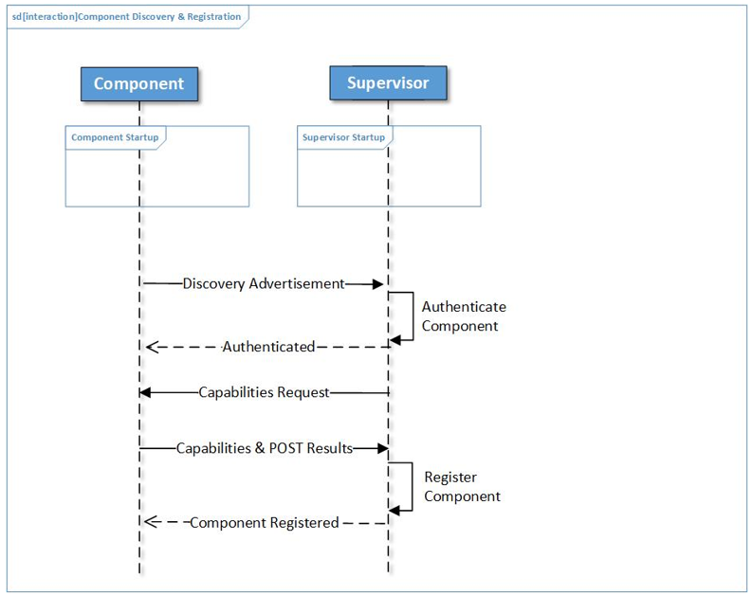

Figure MDIRA RI - Example Component Discovery Sequence Diagram (Abstract)

The above model is “abstract” in the sense that it may be implemented using many different connectivity technologies and does not require, for example, use of ISO/IEEE 11073 SDC constructs. In this sequence diagram the two actors (MDIRA Supervisor and MDIRA Component) interact when a Component is connected to the network:

1. Component notifies the network’s Supervisor of its presence
2. Supervisor first authenticates that it is a valid Component and then issues a “capabilities” request
3. Component provides its capabilities (e.g., data and services provided) along with its “component health status”, in this case reflected by its “POST Results”
4. Supervisor completes the MDIRA Component discovery, authentication and registration process, and notifies the Component of its status

At this point, the Component is connected; however, it must wait for the Supervisor to explicitly authorize and configure[7] its interactions with other components on the network.

Note: MDIRA / ICE defines a centralized operational environment control and context management function[8], in contrast with the 11073 SDC Service Oriented Architecture device-to-device approach. For the purposes of this MDIRA profile, although it will leverage the SOA-based SDPi profiles, it will further constrain them to enable centralized Supervisor management approach illustrated above. See “SOA on ICE” below for additional perspective.

*Figure 5* below related to the MDIRA RI illustrates how the component discovery functionality generally depicted in *Figure 4* might be achieved utilizing ISO/IEEE 11073 SDC constructs (e.g., message specifications):

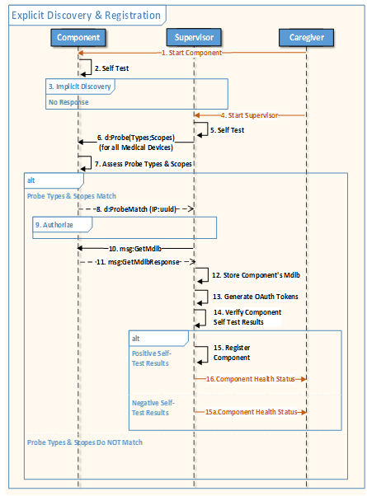

Figure MDIRA RI - Example Component Discovery & Registration Sequence Diagram (SDC based)

Note that a “Caregiver” external actor is now added to the sequence diagram, illustrating the interactions between MDIRA components and the person overseeing their use (the “ICE” system) to provide therapeutic care. Step #1 “Start Component” reflects the user’s turning on the Component (e.g., physically or logically), to kick-start its operation. Step #3 shows that the component may issue an SDC “implicit” notification of its presence, but if this happens before the Supervisor is active (step #4), the notification is “missed”. In this case the Supervisor will explicitly “probe” for all the components that are connected on the network (step #6) and then for each component, perform the MDIRA functions called out in Figure 4, and ultimately notify the user of the presence of each component along with their component health status (e.g., results of POST and discovery & registration, both operational and non-operational status).

Step #13 also indicates the use of OAuth tokens per component to support authorization. The MDIRA RI utilizes Oauth tokens to manage authorization of components and their configured services provided to the other networked components.

Note: This is a departure from the approach taken in IEEE 11073 SDC / MDPWS, and may be continued in the MDIRA profile or included as an option or similar.

Component health status reporting is another high-level MDIRA function for dynamic monitoring of a components ability to provide its expected services:

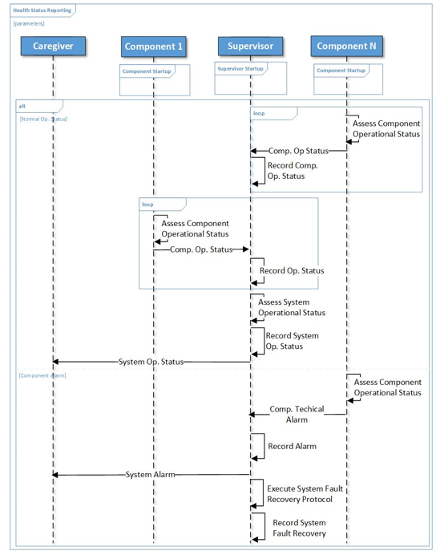

Figure MDIRA RI - Example Component Health Status Reporting Sequence Diagram (Abstract) [9]

In a MDIRA implementation, each component is required to periodically (or upon request) reports its Component Operational Status (“Comp. Op Status”) to the MDIRA/ICE Supervisor, enabling dynamic assessment of overall system “health”, including safety, effectiveness and security (SES). In the above sequence diagram:

1. Each component periodically “loop” assesses and reports its operational status
2. Component *technical alarm* is raised if it determines that there is an issue with its ability to perform as expected
3. Caregiver is notified both of system operational status, as well as any technical alerts reported by components
4. Supervisor is also responsible for determining and executing a fault recovery protocol to ensure the SES operation of all components (e.g., may include taking a component off-line or notifying the user to replace a given component)

Note that the MDIRA/ICE Data Logger actor (see *Figure 2*) will, in parallel to the above component health status reporting, be recording detailed data that may be subsequently used for fault analysis and quality assessment and research.

**New actors**

Based on the above discussion (i.e., *Figure 1* to *Figure 6*), the following *Figure 7* MDIRA Actor Model concept proposal leverages both the MDIRA component model and the approach taken for the SDPi profiles (see *Figure 8* below):

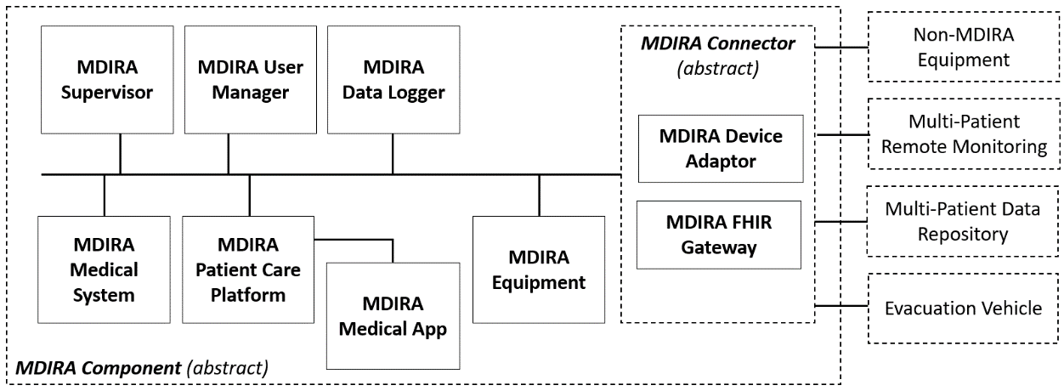

Figure IHE MDIRA - Actor Model (proposed)

In addition to the sources that inspired this notional actor model, there were numerous considerations:

1. ***Actor Names*** –
   1. Does “MDIRA” have to be pre-pended to each actor name? Why?

* Primary rationale is the same here as for the SDPi profiles actor names: these actors are also published in an IHE TF Volume 0 appendix where similar actor names may be included in other IHE profiles. Also this will keep these actors grouped when referenced outside the scope of the profile specification.
  1. Should alternatives be considered such as “ICE” or “SDPi ICE xyz” or “MDIRA ICE”?
     + Alternatives can always be considered, especially during early profile review before it goes to formal approval and publication.
     + The point here is that this profile represents an effort to cast ICE (AAMI 2700-x) model components using IHE TF constructs. Perhaps the actor names could convey this ICE-iness more clearly
     + The model above represents a starting point, but will be further considered during specification drafting

1. ***Actor Integration & Transactions & Network Connection –*** 
   1. Note that in most IHE profiles, inter-actor transactions are indicated directly on the actor model (e.g., see ITI XDS.b or RAD SWF actor diagrams); however, given the plug-and-trust networked architecture for these actors, along with the number of actors, it was determined that the transactions may be omitted from the diagram and contained in subsequent tables within the profile. (note: this is similar to the SDPi-P actor model below)
   2. To show actor multi-way integration, though, which is generally between all MDIRA Components, a network integration “bus” approach is utilized;
   3. Note that only one component is not connected to the network, namely the MDIRA Medical App (see rationale below in actor description section)
2. ***Remote Connections + External (Telemedicine) User Actors –*** 
   1. Not included in the model are the remote users and clinicians that might interact with the integrated MDIRA components for a single patient. This topic will be addressed during the development of the MDIRA profile
   2. Additionally, this model does not indicate explicitly remote (e.g., cloud infrastructure) connectivity, although that is called out in the MDIRA model above. Again, this will be addressed during development of the profile.
   3. See also MDIRA User Manager actor below.
   4. Additionally the Gemini SES RCC/MH[10] Technical Report may provide additional informative detail for this aspect of the discussion
3. ***MDIRA Connectors & External Actors –*** 
   1. Clearly not all possible external actors are represented on this model, especially when considering the MDIRA graphics above
   2. Similarly, only a few of the possible MDIRA Connectors are called out on the model above
   3. For the purposes of this document, the external actors are those which will clearly be included in version 1 of the profile specification; however, additional external actors and connectors/gateways are expected to be added as needed
4. ***Robots? Devices? MEE/MES? Regulated / Non-Regulated –*** 
   1. Many other actors and concepts could be layered onto this already busy actor model, but for the near term focus of the specification, they will only be addressed in the discussion content of the profile.
   2. Regulatedness is also generally not identified on the actor model; however, ***medical*** is used for the titles of two of the actors (MDIRA Medical System and MDIRA Medical App); for both of these the intent is that they will explicitly support technologies that have a medical purpose and are thus generally subject to regulatory oversight of some sort. Note that this is also the rationale for the SPDi-Reporting / -Alerting / -externalControl profiles, each of which has an explicit medical purpose for its transactions (e.g., and thus explicit mappings to ISO/IEEE 11073-1070x Participant Key Purposes (safety) standards
   3. Conversely, the use of “***equipment***” indicates that it does not have an explicit medical (patient care) purpose. Note that the connectivity capabilities would then be fully addressed in the SDPi-P profile.
   4. Use of the IEC 60601 terms “medical electrical equipment” (MEE) and “medical electrical systems” (MES), which are called out on an earlier MDIRA graphic above, but for the purposes of this profile specification, will not be explicitly differentiated; however, discussion on the topic may be included in a general profile considerations section
5. ***SAMD & Health Software & “Apps”*** 
   1. As discussed above in the discussion “SAMD “Therapy Coordinator” Application(s)”, the MDIRA actor model makes explicit provision for medical software applications or “medical apps”
   2. Not explicitly called out on the model is the fact that the other actors may be implemented solely as health software[11] applications, including Software as a Medical Device (SAMD); in this case, every MDIRA Component may be implemented as software-only on general purpose hardware (e.g., Raspberry Pi!) or as purpose-built software-hardware such as for infusion pumps and ventilators; the MDIRA actor specifications should not change significantly (if at all) based on the implementation technologies utilized
   3. The linkage between a MDIRA Medical App and the MDIRA Patient Care Platform actors represents a standard *“API” for apps* that may run on a general purpose, though “medical grade”, platform; this API will also leverage the similar linkage on *Figure 8* below between a SOMDS platform and (external) health software app
   4. Finally, SAMD implies a software application that supports one or more medical purposes, and as a result may be regulated by governing authorities; health software is a more generic term that includes SAMD and SIMD (Software In a Medical Device);
   5. MDIRA profile will support health software applications in the broadest sense
6. ***“ICE on SOA”: MDIRA/ICE over SDPi/SOA***
   1. As mentioned above in Footnote 8, MDIRA and ICE include a *centralized* clinical environment operational control “Supervisor” function; whereas SDC / SDPi are based on a purely *de-centralized* participant-to-participant SOA architecture (“MD-SOA”)[12]
   2. Arguably they are generally two sides of the same coin, with one being configurable as the other; for example, a MDIRA/ICE ecosystem could be configured such that when a component is discovered and registered, it is granted authorization to proceed without any further constraints
      * On the flip side, core functions in a MDIRA/ICE implementation are required and cannot be subject to configuration (e.g., mandatory Supervisor, Data Logger actors and Discovery / Registration and Component Health Status reporting)
      * These functions can be realized in an SDPi/SOA implementation, but they have to be explicitly added and at this point, in a non-standardized way
      * Thus MDIRA/ICE and SDPi/SOA are complimentary … two sides of the same coin
   3. In a Hanging Gardens framework … “universe” … both MD-SOA (Medical Device SOA, as expressed in IEEE 11073 SDC) and MDIRA and ICE all exist in the Architectures & Frameworks layer, but they do not do so exclusively: MD-SOA, ICE and MDIRA “mappings” may be defined enabling implementations that satisfy the requirements of each; this is a primary objective of the IHE MDIRA profile
   4. This is pragmatically realized by the pedigree of the MDIRA actor diagram (*Figure 7*) above from IHE SDPi (SOA) profile, the MDIRA models, and the ICE framework.

To reiterate: *Figure 7* is a “notional” model concept for the purposes of this Detailed Profile Proposal. As the project team works through profile specification development, it is anticipated that the proposed actors will not only be clarified but also that some may disappear, and others appear. For the purposes of DPP, though, the model provides a good general understanding of what is being undertaken.

The following actor descriptions are based on the MDIRA Specification (2.0) and an ISO/IEEE 11073 SDC-based MDIRA reference implementation. ***These actors and their descriptions are not finalized*** (the final profile may add or remove or renovate actors) ***nor comprehensive*** (specific functionality will be modified).

Note: In this profile, although MDIRA “component” will generally be equivalent to IHE “actor”, this mapping is not absolute.

**Actor: MDIRA Component** (*Abstract*)

All “concrete” MDIRA actors inherit from this abstract actor. It provides common capabilities, “ground rules”, that are required both during network discovery and connection, as well as dynamically during operation. This is especially the case for requirements such as security and authorization.

Additional considerations:

1. MDIRA makes no explicit distinction of the SOA / SDC Provider and Consumer roles, which are the primary actors of the SDPi-P model (Figure 8); it is assumed that this distinction as relates to MDIRA actors will be achieved “under the hood” in specific actor specifications
2. Provider & consumer-provider only – Given that all MDIRA RI (non-Supervisor) components *provide* Component Health Status (see earlier discussion) as well as updates to the Data Logger actor, there are no pure “consumer” components in a MDIRA/ICE system.

Optionality: This is a REQUIRED actor (grouped with every other MDIRA profile actor).

**Actor: MDIRA Supervisor**

The Supervisor is an ICE component that includes the following functionality:

* Discover, register and deregister other MDIRA components
* Authorize all MDIRA Provider and Consumer relationships / interactions
* Receives and monitors MDIRA Component health and operating status data, including *technical* alerts
* Displays MDIRA System (ICE / SOMDS) health status, component connection status, physiological / technical alerts to users / clinicians
* Supports fault recovery protocols (when component health failure is detected)
* Ensure time synchronization to a common system clock
* Manages system- and care-context information

Additional considerations:

1. MDIRA profile will ensure consistency with similar IHE profile (esp. SDPi) functional system concepts, such as those in SDPi TF-1 Appendix C.1 (e.g., Dashboard, Cockpit, Alert Distributor[13], etc.). Additionally, *Figure 1* “ICE Management Components” may be realized utilizing these component system concepts as well
2. Supervisor component context management will leverage the SDPi-P Option: System Context Management, including capabilities for SDC:SystemContext, LocationContext, PatientContext, EnsembleContext, OperatorContext, WorkflowContext configuration within MDIRA registered components
3. Supervisor may monitor QoS / QoD dynamically and based on component-specific risk managed “permits” (see 80001-1 1st edition), identify yellow or red “fault” conditions
4. Supervisor may need to support detection of “unauthorized” traffic between components, including non-MDIRA exchanges between rogue actors! (note the Data Logger below may also support this post-episode of care determination)

Optionality: This is a REQUIRED actor. Only one per MDIRA system environment.

**Actor: MDIRA Data Logger**

The Data Logger is an ICE component that provides the following functionality:

* Store system (MDIRA Components) and patient data during an episode of care for later download to an information system for performance, forensics, and care quality analysis
* Record all messages exchanged between MDIRA Components
* Record MDIRA Component internal status information of relevance (e.g., component authorization request to its Supervisor, status of interface to external non-MDIRA systems) for forensics and quality analyses
* Provide Data Logger component health status to the MDIRA Supervisor (*not* the current health status for all components – they report directly to the MDIRA system Supervisor)

Additional considerations:

1. Data Logger will support AAMI 2700-2-1 ICE data logger standard; however, “level of conformity” will be detailed in the MDIRA profile to ensure near term achievable adoption and implementation
2. Data Logger is simply a … log; no real-time intelligence is included; only support for post-episode of care analytics (per the description above);
3. MDIRA profile should allow for both centralized and distributed data logger implementations; note this is similar to IHE XDS.b Registry implementations, as well as MD-SOA with a distributed Registry (and no central registry – as a simplification strategy);

Note: this capability is currently supported by the MDIRA SDC-based RI

Optionality: This is a REQUIRED actor. Only one per MDIRA environment.

**Actor: MDIRA User Manager**

The MDIRA User Manager provides a service to ensure that only authorized individuals (e.g., clinicians, clinical engineers, etc.) are allowed to directly interact with a MDIRA system. This actor supports the roles defined in the “Users” element in Figure 1, as well as the “User Manager” in Figure 2. Though not called out on the preceding MDIRA sequence diagrams (e.g., *Figure 5* and *Figure 6*), interaction with the “Caregiver” in these sequences implies that the individual is authorized by the User Manager, to interact with MDIRA system components.

Additional considerations:

1. Specifications related to this actor are primarily captured in the MDIRA (2.0) specification, section 5.4
2. This actor does NOT support the means for interacting with a given user or component (e.g., user interface technologies)
3. Authenticated / authorized users (and those not) are also recorded in the Data Logger
4. The specific technologies and means for identifying and authenticating a given user is outside the scope of the MDIRA profile
5. For MDIRA using SDC/SDPi, the SDC:OperatorContext will be managed by the MDIRA Supervisor to appropriately inform MDIRA Components of the currently authorized users
6. The User Manager may also include support for authorized “roles” that allow for a given user to access MDIRA Component functions (such as starting an infusion pump or hot-swapping a failed component)

Optionality: This is an OPTIONAL actor. Only one per MDIRA environment.

**Actor: MDIRA Medical System**

The Medical System actor conforms to the MDIRA Component and provides medical capabilities to the MDIRA system, including other networked components. These systems may provide therapeutic and diagnostic services such as physiological monitoring or medication administration, and as such they play key roles in supporting autonomous / closed-loop control SDC “ensembles”. Their MDIRA/ICE participation is managed by the MDIRA Supervisor actor.

Additional considerations:

1. As indicated on *Figure 1,* these actors support the IEC 60601 concepts of MEE/MES, but may also be implemented as SAMD
2. Although MDIRA Components will rely on SDPi-P health purpose connectivity, MDIRA Medical Systems will rely on the specific medical purposed SDPi profiles, namely SDPi-R, SDPi-A, and SDPi-xC
3. In the case of an alert dashboard, these actors may support SDC alert delegation (i.e., as primary alerting systems)

Optionality: This is an OPTIONAL actor. Zero to many per MDIRA environment.

**Actor: MDIRA Medical App**

The Medical App is a software application that provides a medical (therapeutic & diagnostic) purpose but is intended to operate on a general purpose platform (vs. purpose built hardware). It is represented in *Figure 1* as SAMD and in *Figure 2* as SAMD Applications such as Therapy Coordinator. This actor may be differentiated from the MDIRA Medical System actor above in that it does not need to support the complete MDIRA profile connectivity infrastructure (e.g., SDC/SDPi interoperability), but can instead be built to a much more targeted API supporting the high-level functions needed for application execution, including more granular discovery (at the data element level), and algorithm risk-managed capabilities such as quality of service requirements for SES. The MDIRA Medical App is analogous to the HL7 SMART on FHIR specification for platforms and applications.

See related MDIRA Patient Care Platform actor below.

See previous discussions related to health software and health “apps”.

Additional considerations:

1. This actor will specialize the SDPi-P (external) “Smart Apps” actor, with the difference that it is integrated into the scope of the MDIRA profile (see earlier discussion on this rationale)
2. This actor does not identify specific types of apps, such as Therapy Coordinator App, or Closed-Loop Control (CLC) App, or Autonomous Intelligence App, etc.

Optionality: This is an OPTIONAL actor. Zero to many per MDIRA environment. (Requires at least one Patient Care Platform instance).

**Actor: MDIRA Patient Care Platform**

This Patient Care Platform provides an environment for software applications, both medical and health “apps”, enabling them to launch and operate in a medical grade SES platform in such a way that they do not need to support all the capability of a full MDIRA ecosystem but can be focused on their specific algorithmic and service system function contribution (SFC).

The platform API is a key element of this actor.

See preceding MDIRA Medical App actor description.

Additional considerations:

1. This actor will specialize or “leverage” the SDPi-P SOMDS Smart App Platform
2. The SOMDS platform actor is currently based on the SOMDS Connector (abstract) actor due to the fact that SMART Apps are external to the SDPi SOMDS environment; this actor, though, and its Medical App counter part are all within the MDIRA environment and therefore are not required to leverage the MDIRA Connector capabilities;
3. Should also consider the kinds of apps that might be supported, not only SAMD medical apps but health software that may operate on a patient care platform
   1. Note: SAMD is a kind of health software; however, additional non-medical apps may be supported as well, such as environment controls that have no direct intended medical purpose
   2. For this actor’s name, though it does not include Medical & Health Apps, for simplicity, health software is intended to be included.
4. SDPi concepts such as “cockpit” and “dashboard” should be considered as well
5. Since the platform API specification is irrelevant without the platform, it is an optional actor and not a profile option (e.g., Platform API Option)
6. In fact, the inclusion of an API is the primary differentiator between this platform actor and SAMD that is deployed as a MDIRA Medical System on virtualized (but general purpose) platform hardware

Optionality: This is an OPTIONAL actor. Zero to many per MDIRA environment.

**Actor: MDIRA Equipment**

The Equipment actor provides connectivity to a MDIRA environment for those systems (devices and health software applications) that do not support a medical (diagnostic or therapeutic) purpose but do provide general services that may be utilized in a healthcare use context. For example, environmental controls or location tracking of stuff and people, etc.

Additional considerations:

1. This actor would utilize SDPi-P but not -R -A -xC, all of which are intended for medical purposes and are linked to specific MDI constructs + PKP standards that ensure SES operation
2. Note that in this case, non-regulated technology may not generally apply; in other words, non-medical does not imply non-regulated; for example, equipment operating in an acute care environment will have to comply to certain “medical grade” requirements such as power and electrical noise emissions.

Optionality: This is an OPTIONAL actor. Zero to many per MDIRA environment.

**Actor: MDIRA Connector**

As stated in “*MDIRA Connectors & External Actors*” above, integration of non-MDIRA enabled technologies is a practical reality – both due to the present persistent lack of basic MDI “from the device interface” as well as interfacing with technologies that are designed for primary operation in other use contexts (e.g., multi-patient EHR systems). This abstract actor provides a common set of capabilities required for any of these adaptors or gateways to interface with a MDIRA environment. It corresponds to the “Interfaces to External Systems” component in *Figure 1* above.

See also MDIRA Device Adaptor, and MDIRA FHIR Gateway concrete actors below, each of which specializes this MDIRA Connector actor.

Note: *MDIRA V2 Gateway* and a related *MDIRA IHE DEV PCD Gateway* are not currently called out here, even though the MDIRA RI in Figure 2 includes some external actors that integrate using IHE DEV PCD profiles. This may be an early adaptation during the profile development and would be predicated on their SDPi actor counterparts

Additional considerations:

1. The MDIRA Connector is analogous to the SDPi SOMDS Connector actor in Figure 8 below.
2. Extension to the baseline SOMDS Connector should reflect the unique MDIRA actor and transactions / services environment; unique external actors including robots should be handled in specialized concrete MDIRA Connector-based actors
   1. In other words, the detail here should be minimized, leverage that of the SDPi SOMDS Connector actors that they leverage
3. For the purposes of this profile, only a few “connectors” are identified, namely Device Adaptor and FHIR Gateway; however, more may be added as needed and these two may be “morphed” into something more targeted
   1. For example, “device” is used but it could also be system or application or any number of terms; in this case it is a generic use of the term “device” and should be quickly understood by the broad set of stakeholders
4. MDIRA Connectors are intended to be bi-directional – providing a means to MDIRA Components to access external services and information, as well as to provide information from MDIRA Participants to external systems (e.g., patient information to a remote telemedicine system)

Several external actors / systems are also indicated on the diagram above; however, these will be detailed out during profile development:

**External Actor: *Non-MDIRA Equipment***

Given the general lack of MDI interfaces on medical and non-medical equipment that are primarily intended be integrated into a MDIRA Network (e.g., ventilator), a MDIRA Connector actor will be required; See MDIRA Device Adaptor below.

**External Actor: *Multi-Patient Remote Monitoring***

MDIRA supports connection to remote care systems including telemedicine support. As indicated in *Figure 1*, as is often the case in “austere” (disaster) environments, multiple patients may be simultaneously supported and thus care coordination across multiple MDIRA systems would be necessitated. For example, depending on patient acuity, evacuation for some patients may be prioritized over others who are more stable and less critical.

**External Actor: *Multi-Patient Data Repository***

MDIRA actors will need access to remote electronic health records (EHR) and medical records systems (e.g., via a “cloud” connection). See the MDIRA FHIR Gateway below as a key technology that might be used for this integration.

**External Actor: *Evacuation Vehicle***

Ultimate evacuation of the individual to a tertiary care facility is a primary objective of the MDIRA use cases, and this will involve some form of an evacuation vehicle or medical transport system. Inclusion of this external actor foreshadows potential future extensions of this profile (or another) to provide this type of connectivity.

Optionality: This is an OPTIONAL actor but is required for integration of any “External Actor” systems and applications.

**Actor: MDIRA Device Adaptor**

The Device Adaptor actor directly supports the connector requirements identified by the red-green adaptor boxes in the MDIRA RI Figure 2. Primary support is to enable integration of existing off-the-shelf equipment (medical and non-medical) into a MDIRA environment. Per *Figure 2* this would include infusion pumps, physiologic monitors, ventilators, etc. It may also be utilized to support interfacing to other non-MDIRA technologies that require specialized adaption for vendor specific (proprietary) protocols.

Note: Standardized protocols (such as FHIR or SDC or HL7 V2) should be realized in specialized actors such as the “FHIR Gateway” below

This actor is specialized from the MDIRA Connector.

Additional considerations:

1. Whereas standardized protocols and have a MDIRA (SDPi) to protocol mapping / adaption layer that is also standardized as part of this profile specification, vendor or other industry specific protocols should be supported by this actor – perhaps including a “container” for integrating the two sides of the equation; in this sense it might be a “Device Adaptor (Philips Monitor Protocol)” designation
2. Note that there is no clear SDPi actor that is the same as the Device Actor; in SDPi-P it is assumed that a vendor-specific “adaptor” would be created as a specialized version of a SOMDS Connector, with CA testing being on the SOMDS-side of the connection and the “mapping” component being that supporting the specific vendor’s protocol.

Optionality: This is an OPTIONAL actor. Zero to many per MDIRA environment.

**Actor: MDIRA FHIR Gateway**

The FHIR Gateway actor provides a general means of interfacing with HL7 FHIR-based systems and applications, including for a wide range of patient information and related services (including analytics, decision support, and care coordination). This actor will leverage the significant amount of FHIR implementation guides and IHE FHIR-based profiles that are are currently implemented in products and actively being developed.

Note: This includes support for the U.S. Government’s FHIR Core specifications

This actor is specialized from the MDIRA Connector and leverages the SDPi-P FHIR Gateway actor.

Additional considerations:

1. Consider how best to leverage the Devices on FHIR Implementation Guide specifications, as well as the IHE FHIR-based profiles, especially from the IHE ITI TF
2. …

Optionality: This is an OPTIONAL actor. Zero to many per MDIRA environment.

**Existing actors**

The MDIRA profile will heavily leverage the IHE DEV SDPi profiles, including the following SDPi-Plug-and-trust actors:

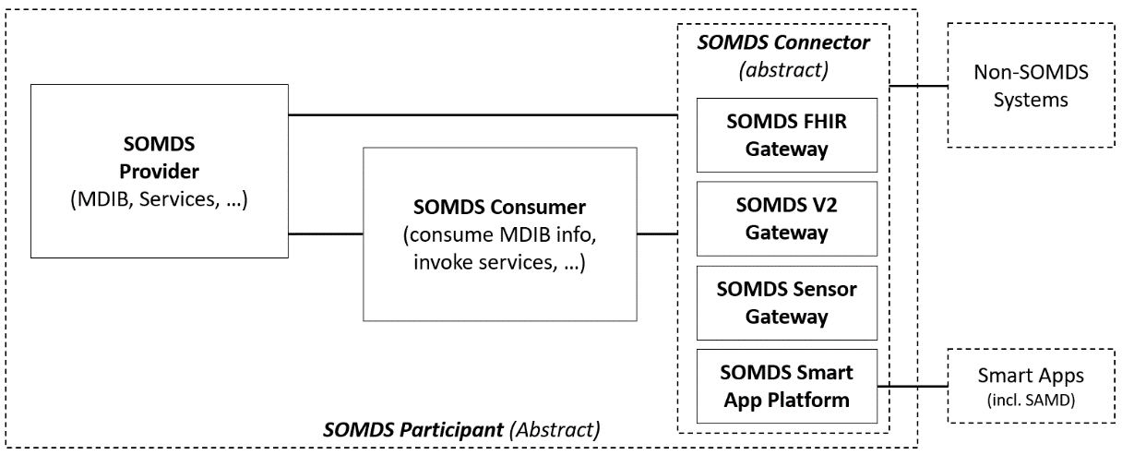

Figure IHE SDPi-P Actor Model

Actors from other SDPi profiles (-R, -A & -xC) will also be included for those MDIRA actors that have an explicit “medical” purpose (see “medical” actors discussions above). Also other IHE profiles (e.g., ATNA or PDQm) will be referenced especially to support some of the proposed external actors, or profiles such as Consistent Time that are required for all IHE profiles and will meet MDIRA requirements as well.

**New TF-3 Semantic Content**

It should be noted that the MDIRA profile will use the same TF-3 semantic content specifications as for the other IHE Devices profiles, including the ISO/IEEE 11073 nomenclature. The profile will leverage the SDPi TF-3 “BICEPS” models but may add additional content profiles, for example, for specific classes of Medical Apps or the Data Logger and Supervisor actors. If this is the case, then the MDIRA profile will either specialize the SDPi-P Content Module specification(s) or define its own content module profile section.

**New transactions (standards used)**

As discussed above in “MDIRA / ICE – Unique Technical Requirements: Actors & Transactions”, the MDIRA specification provides for a unique set of capabilities that add functionality to those that are defined within the SDPi profile. Some of these are illustrated in Figure 5 & Figure 6, and include (not exhaustive):

1. System component discovery and registration
2. Centralized (via Supervisor) component authorization and MDIRA “context” management
3. User identification and authorization capabilities (potentially leveraging ITI profiles)
4. Component operational health reporting and monitoring
5. Data logging for analytics and quality improvement
6. Medical therapeutic automation and closed-loop control between components
7. Fault condition determination and recovery
8. Medical & Health Apps “API”

These functional areas illustrate the kinds of new transactions or extensions of SDPi transactions that are anticipated for the MDIRA profile and thus represent the “value add” of the profile. Effort will be to maximize utilization of SDPi constructs so as to minimize “wheel reinvention” within the MDIRA profile.

Each of these represent significant areas of effort, though. So it is anticipated that profile development shall be phased with the mandatory, core MDI functions established first and then additional capability added as appropriate. For example, a number of the MDIRA actor descriptions above indicate “MANDATORY” actors that will also have baseline functionality specified in the profile, including discovery, registration and authorization, as well as component health reporting and data logging.

See section 8 for additional perspective.

Standards to be utilized are identified above in section *4 Standards & Systems*.

**Impact on existing integration profiles**

Since the use contexts for MDIRA are similar (high acuity point-of-care) but also different (e.g., geographically remote, autonomous medical systems, telemedicine connections, etc.) some additional capability may need to be added to the underlying profiles, such as SDPi-P. For example, an SDPi-P Option for “Remote Connection” leveraging HTTP/2 and gRPC technologies for a transport better suited (and supported) across cloud infrastructure, may be required.

Additionally, implementation priority may need to be adjusted for completion of optional capabilities for the SDPi profiles or the related Devices on FHIR implementation guides.

Finally, though great effort has been made to ensure that the SDPi profiles can be leveraged by other profiles, such as MDIRA, the “proof is in the pudding” and MDIRA profiling may uncover the need to rethink some of the approaches and capabilities included in SDPi.

**New integration profiles needed**

No additional profiles, beyond what are mentioned above, are anticipated as a result of advancing this MDIRA profile project proposal.

Some existing IHE profiles and underlying standards, including the MDIRA specification itself, may be informed and updated as a result of the development of this profile; however, none is anticipated at this proposal stage.

**Breakdown of tasks that need to be accomplished**

The general IHE TF development process will be utilized for this profile, including the current approach for the SDPi Supplement and other Gemini MDI (SDPi+FHIR) elements.

Note that this is intended to be advanced under the umbrella of a joint IHE-HL7 Gemini MDI project as indicated when the Gemini SDPi+FHIR project was launched with a MDIRA use case identified.

Once this Detailed Profile Proposal is approved by IHE Devices domain, the following initial project tasks will be pursued:

1. ***Form the MDIRA Profile project team*** (rooted in the IHE DEV/DPI Program group)
2. ***Create the MDIRA profile project plan + development support tools*** (github, Confluence, etc.)

Note: This will include a general “phasing” of capabilities as mentioned above, as well as drafting schedule and plug-a-thon (PAT) event scheduling

1. ***Scope the capabilities that will be addressed by version 1.0*** of the profile, factoring:
   1. Core use cases to be detailed
   2. MDIRA Specification requirements (including conformity determination)
   3. MDIRA SDC-based Reference Implementation design approaches
   4. Existing capabilities that are provided by other IHE profiles and related standards (e.g., Devices on FHIR Implementation Guide specifications)
2. ***Develop initial content for the MDIRA Supplement and related collateral***:
   1. Use case specifications (targeting TF-1 Appendix C, with Gherkin)
   2. Craft MDIRA conformity ICS “tables” (targeting TF-1 Appendix B)
   3. TF-1 Craft the content for the MDIRA Profile sections (per the template)
   4. TF-2 Craft the unique MDIRA Transactions specifications + any transaction implementation technology profiling / bindings in an Appendix
   5. TF-3 Craft any MDIRA specific content modules
   6. Generate requirements specifications for tooling / CA support:
      1. See SDPi proposed use of ReqIF for IHE TF requirements management and traceability (including use case Gherkin-to-ReqIF transformation)

Note: Continuous “build” will be an objective during the development of the specification (similarly to what is done with the HL7 FHIR specification)

* + 1. May require creation of MDIRA specification ReqIF requirements specifications
    2. Develop (incl. generation) test scripts and protocols to be used for CA testing and reporting

1. ***Implementation Support / Plug-a-thon Testing Events***
   1. Open source libraries both from the MDIRA project team as well as the SDC / SDPi community should be advanced to ease profile adoption and prototyping
   2. Tools should be adapted (e.g., from SDC/SDPi) to support testing, PAT and conformity testing activities
   3. PAT schedule and specific functionality targets should be identified and advanced
2. ***Finalize MDIRA Supplement (1.0)*** for advancement through IHE DEV to Trial Implementation (TI) publication status
3. <normal IHE processes from this point forward>

Once the MDIRA Supplement 1.0 TI is published, the support community can advance formal IHE Connectathon (CAT) testing, notionally early 2022 at the IHE USA Connectathon, as well as demonstration and educational events. Development of subsequent iterations of the MDIRA Supplement may begin in parallel depending on the project team’s bandwidth.

Ultimately, in 2022 or 2023 the profile will have been tested in sufficient IHE CAT events that it can be advanced to Final Text (FT) status and ready for product Conformity Assessment and ultimately certification.

# Risks

Key project risks associated with the MDIRA profile include:

1. Project team “resources” & continuity – support and community to advance the profile’s development and ensuring that those SMEs who have worked on MDIRA to date are able to stay engaged to ensure continuity and advancement
2. Completion of the required elements of the underlying SDPi+FHIR profiles and specifications
3. Availability of open source libraries and test tooling to lower any barriers to adoption and prototyping (e.g., PAT & CAT events)
4. “Market Demand” from industry for the unique capabilities provided by a MDIRA/ICE ecosystem of compliant products

# Open Issues

Known challenges for the MDIRA profile that need to be addressed early in the supplement development include:

1. Consensus by the project team and broader MDIRA/ICE community on the design approaches being taken for the profile (i.e., Technical Approach detailed above)
2. Clear specification of how MDIRA conformity will be claimed and assessed
   * Current MDIRA specification includes clear requirements and *generally* how implementation conformity may be determined; however
   * Specific groups or “profiles” of requirements that would constitute valid conformity are yet to be specified
   * Near term, MDIRA profile will specify general requirements per what is available in the specification in accordance with the approach taken by the SDPi Supplement (including TF-1 Appendix B tables)
   * Longer term, there is a risk that the MDIRA Specification will add more extensive conformity requirements and models that could prove difficult to integrate into the MDIRA profile supplement
3. Creation of definitive requirements specification utilizing ReqIF or similar
4. Maturity and “implementablity” of the standards and profiles upon which the MDIRA specification and the MDIRA profile are built.

For example, the MDIRA/ICE Data Logger actor will include support for the AAMI 2700-2-1 standard; however, some vendors have indicated that some requirements within the standard cannot be *realistically implemented* in production systems.

1. Resolution of key design approach differences between MDIRA and the SDC/SDPi profiles

For example, MDIRA RI utilizes OAuth tokens for component registration and authorization; whereas the SDC / SDPi profile utilizes the provisions in the ISO/IEEE 11073-20702 MDPWS standard (WS-Security based).

1. …

# Effort Estimates

Once approved, a relatively small project team (e.g., 5 SMEs) can advance development of the MDIRA profile to the 80% stage by midyear 2021. This would be tasks (1) through (4) above. At that point, reassessment of the Risks and Open Issues identified above, as well as ensuring that an adoption / implementation community is ready to support TI publication and PAT / CAT events.

Note: the project team will ensure scoping of the initial set of capabilities to help ensure successful development of the version 1.0 supplement.

If this community is ready, then finalization of the MDIRA Supplement (version 1.0) can be accomplished by the project team by late Q3 2021 and PAT / CAT planning progressed for 2022.

Core development is planned by the IHE DEV/DPI Program group, but will be pursued in the same open community approach taken by the other IHE-HL7 Gemini MDI projects.

1. See JHU/APL references in section 3 below.
2. In this document, “MDIRA/ICE” is used when emphasizing the ICE framework aspects in the MDIRA specification.
3. SES MDI = Safe, Effective & Secure Medical Device Interoperability; see Gemini MDI project materials for more information. As well as SDPi Supplement TF-1 Appendix A for a summary of SES MDI as it will be applied for this MDRIA profile.
4. In other words, most device informatics is achieved using gateway architecture with proprietary protocols utilized directly “from the device interface”.
5. Note: Since the “ICE Management Components” are not further specified, for example, in data elements or inter-component transactions, the concept is not formalized in Figure 7 MDIRA Actor Model below. This of course, could change in future versions of the MDIRA specification.
6. Source: Figure 22 *Alternative Mapping of IEEE 11073 SDC to ICE Conceptual Model*, IHE SDPi White Paper (2019).
7. In this case, “configure” includes functions such as component system context management, including formation of SDC ensembles.
8. Note, it might be said that MDIRA/ICE represents a “hub-and-spokes” architecture model; however, this is different from a pure centralized Manager/Agents model such as utilized for the IEEE 11073 Personal Health Device (PHD) or “Classic” 11073 DIM architectures that required all device (“Agent”) interactions to occur through a single Manager system.
9. Source: MDIRA Specification (draft, 2.0).
10. Safe, Effective and Secure Remote Connected Care / Mobile Health (SES RCC/MH) Technical Report; see <https://confluence.hl7.org/x/_BDxB>.
11. See ISO/IEC 82304-1 and ISO/IEC 81001-1 for explicit definitions of “health software.”
12. MD-SOA (Medical Device – SOA) refers to the general architectural approach that the 11073 SDC standards take to implementing SOA, but without the specific constructs of the three core SDC standards. It references that model as it might be represented in the Hanging Gardens “Architectures & Frameworks” layer.
13. Note the Supervisor’s handling of component technical alerts here and in previous diagrams such as *Figure 6*.